Arch Street Tower
Boston (Region I) Training Facility
33 Arch Street, 10th Floor, Suite 1001A, Boston, Massachusetts 02110
POC: Ms. Esther A. Callum, RTF Coordinator (617) 289-0143

Subway
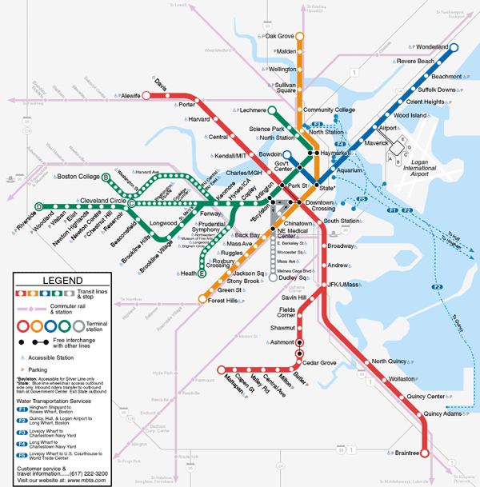
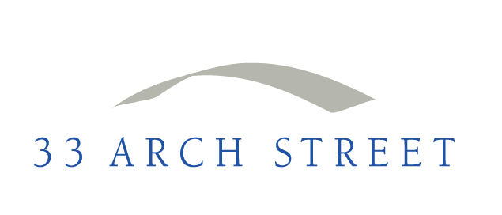

Arch Street Tower is just a short walk from all four MBTA Subway Lines.

From Park Street Station (Green and Red Lines): Exit station onto corner of Boston Common. Walk up Tremont Street away from the Park and turn right onto Bromfield Street just past Suffolk Law School. Cross Washington Street through Downtown Crossing and turn left onto Hawley Street. Enter Arch Street Tower.

Boston Regional Training Facility Information

Boston Regional Training Facility Information (cont’d)

From Downtown Crossing Station (Orange and Red Lines): Exit station onto Washington Street. Turn right and walk along Washington Street until you see Marshall’s. Turn right onto Franklin Street and then left onto Hawley Street. Enter Arch Street Tower.

From State Station (Blue and Orange Lines): Exit station onto Washington Street. Turn left and walk along Washington Street. Turn left onto Franklin Street and then left onto Hawley Street. Enter Arch Street Tower.

Commuter Rail

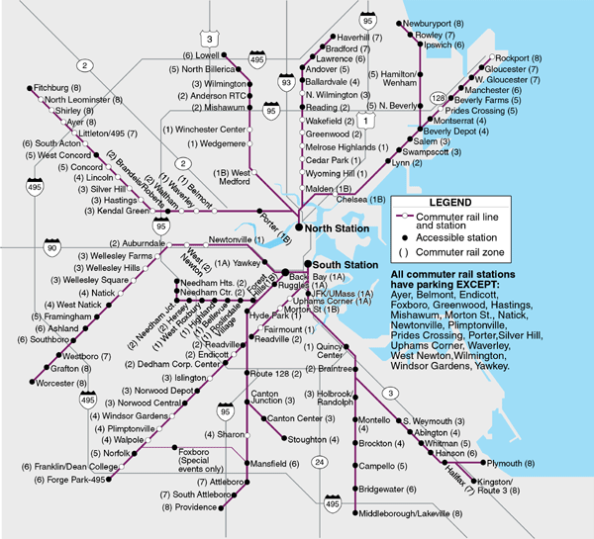

Arch Street Tower is just a short walk from both
North Station and South Station.

Boston Regional Training Facility Information

=====================================================================

Boston Regional Training Facility Information

From North Station: Walk along Causeway Street toward Lancaster Street. Turn left onto Merrimac Street. Merrimac becomes Congress Street. Follow for about half a mile and then turn right onto Franklin Street. From Franklin turn left onto Arch Street. Enter Arch Street Tower.

From South Station: Walk along Summer Street away from South Station. Turn right onto Devonshire Street and then left onto Franklin. Follow Franklin and turn right onto Arch Street. Enter Arch Street Tower.

Bus

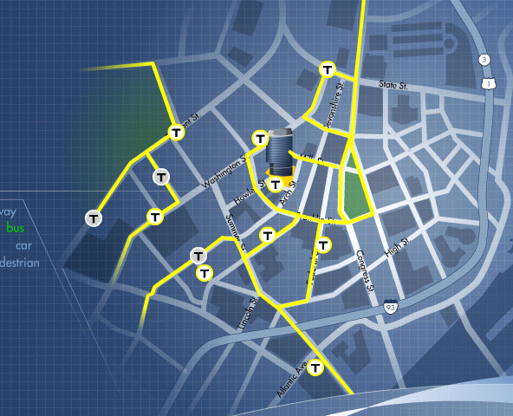

Bus Routes #92, 93, 459, 7, 504, 553, and 558, among others, are easily accessible from Arch Street Tower. Also, South Station is less than half a mile away, offering long distance bus service to Cape Cod, New Hampshire, New York and points beyond.

Bus Stops are located on Franklin Street, Milk Street, Devonshire Street, Washington Street, Federal Street, Otis Street, and Summer Street – all of which are within easy walking distance from Arch Street Tower.

Please visit the MBTA Website www.mbta.com for complete schedules and station information.

Boston Regional Training Facility Information

Boston Regional Training Facility Information

Helpful Transportation Websites:
www.massport.com/logan Logan Airport Website
www.amtrak.com Amtrak Website
www.masspike.com Mass Turnpike Website
www.p-b.com Plymouth & Brockton Bus Lines (South Shore/Cape Cod)
www.peterpanbus.com Peter Pan Bus Lines (Multiple Destinations)
www.fungwahbus.com Fung Wah Bus (Boston to New York)
www.bonanzabus.com Bonanza Bus Lines (Multiple Destinations)
www.greyhound.com Greyhound Bus Lines (Multiple Destinations)

Driving Directions - From Points West

take the mass turnpike (i-90) eastbound toward boston/logan airport.
- Take the I-93 exit (Exit 24 A-B-C) on the left toward Concord NH / South Station
- Take Exit 24A toward South Station
- Turn left onto Kneeland Street
- Turn right onto Lincoln Street
- Turn left onto Summer Street
- Turn right onto Devonshire Street
- Turn left onto Franklin Street
- Turn right onto Hawley Street
- Enter 33 Arch Street Garage

From Logan Airport

Take the Mass Turnpike (I-90) Westbound
- Take Exit 24-25 toward I-93 North / South Boston
- Keep right at the two forks in the ramp
- Turn slight right onto Congress Street
- Turn slight right onto D Street
- Turn right onto Summer Street
- Turn right onto Devonshire Street
- Turn left onto Franklin Street
- Turn right onto Hawley Street
- Enter 33 Arch Street Garage
- Boston Regional Training Facility Information

Boston Regional Training Facility Information

From Points North

Take I-93 South toward Boston
- Take the Purchase Street exit, Exit 23 toward South Station
- Stay straight to go onto Purchase Street
- Turn right onto Pearl Street
- Turn left onto Franklin Street
- Turn right onto Hawley Street
- Enter 33 Arch Street Garage

From Points South

Take Rte 3 North to Rte I-93 North (Southeast Expressway)
- Take Exit 20 toward 1-90 Logan Airport / Worcester / South Station
- Take the Frontage Road exit on the left toward South Station
- Turn slight right onto New Frontage Road North / Frontage Road
- Take the Kneeland Street ramp
- Take the ramp toward South Station / Downtown
- Turn left onto Kneeland Street
- Turn right onto Lincoln Street
- Turn left onto Summer Street
- Turn right onto Devonshire Street
- Turn left onto Franklin Street
- Turn right onto Hawley Street
- Enter 33 Arch Garage

boston regional training facility information

boston regional training facility information

From 33 Arch Street to Major Highways

To Routes 90 (Mass Pike) and 93:

- Turn right out of parking garage onto Hawley Street
- Turn right onto Milk Street
- Turn right onto Congress Street
- Continue straight on Congress and follow signs to both Rte 90 (Mass Pike) and Rte 93 which lead you to a tunnel entrance for both

Restaurants
- Cosi 14 Milk Street (617) 426-7565
- J. Pace & Son One Federal Street (617) 556-8253
- Elephant & Castle 161 Devonshire Street (617) 350-9977
- Archie’s New York Deli 101 Arch Street (617) 330-5145
- Pizzeria Rico 32 Bromfield Street (617) 423-7426
- Sam LaGrassa’s 44 Province Street (617) 357-6861
- Qdoba Mexican Grille 62 Summer Street (617) 357-0791

local bank branches

Bank of America (800) 841-4000

65 Franklin Street
315 Washington Street
100 Federal Street
60 State Street
175 Federal Street

boston regional training facility information

boston regional training facility information

Banks (cont’d)

Citizen’s Bank

77 Franklin Street (617) 551-6153
40 Summer Street (617) 422-8383
28 State Street (617) 725-5900
73 Tremont Street (617) 422-8295

Sovereign Bank (877) 768-8865

One Federal Street
30 Winter Street
1 Beacon Street
125 Summer Street
75 State Street

Wainright Bank

63 Franklin Street (Corporate HQ) (617) 478-4000

Local Copy & Shipping Centers

Copy Cop

260 Washington Street (617) 557-9601
85 Franklin Street (617) 521-8101
77 Milk Street (617) 521-8401

Fed Ex / Kinko’s

211 Congress Street (617) 482-0701
10 Post Office Square (617) 482-4400
252 Washington Street (617) 723-7263

boston regional training facility information

boston regional training facility information

Transportation Services

Taxi
Red White Cab (617) 536-5010
Town Taxi (617) 536-5000

Limo / Chauffeur

Boston Chauffeur (617) 927-5466
www.bostonchauffeur.com

Ultimate (800) 439-4390
www.ultimatelivery.com

Airport

Knights Airport Limo Service 800-822-5456
www.knightsairportlimo.com

Parking Garage Access

Parking garage patrons will be granted access to the lobby upon presentation of their parking ticket. Two-way communication with the Lobby Security Officer is possible through the call stations at both the Hawley and Arch Street doorways. Parking patrons should call the Officer and request entry, present their parking ticket, and proceed to the Pay-On-Foot stations in the Garage Elevator Lobby.

boston regional training facility information

